COMING EVENTS

Term 2

Week 6
Monday 24th May Long Weekend
Tuesday 25th May Uni Computer Comp.
Wednesday 26th May District X-Country
Friday 28th May Gymnastics
Life Education Van Visit
Yr 6 at Hay Public School.
Week 7
Friday 28th May Gymnastics

Week 8
Wednesday 9th June Uni Science Comp
Friday 11th June Hay Small Schools’ Athletics’ Carnival

Week 9
Monday 14th June Queens Birthday Public Holiday
Monday 15 – Friday 18th June Yr 2-6 Borambola Excursion
Wednesday 16th June Mobile Library

Week 10
Monday 21st June Long Weekend
Friday 25th June Yr 6 at Hay Public School

Week 11
Friday 2nd July Crazy Hair Day
Last Day Term 2


BIGGEST MORNING TEA
Carrathool Public School students will be going to the Carrathool Memorial Hall on Thursday 27th May, 2010 to participate in Australia’s Biggest Morning Tea. Please send in a donation with your child.

YR 2-6 BORAMBOLA EXCURSION
Attached to today’s Peppercorn Press is an Information Sheet for Parents.
Final payment for this excursion needs to be paid by Wednesday 9th June.


DISTRICT CROSS COUNTRY
The District Cross Country will be in Deniliquin on Wednesday 26th May (tomorrow) at Memorial Park.
Student are reminded that they are to wear sports clothes and need to take their recess, lunch, drink bottle and hat.
Walk the course commences 10.15 am - 10.30 am
Deniliquin North PS will be operating a canteen.
For the information of competitors/parents:
- Sausage in bread $2 - with onion or coleslaw $2.50, with both $3
- Plain hamburger $3.50, with onion $4
- Tea, coffee $2 Soft Drinks $2 Water $2 Flavoured Milk $1.50
- Chips, liquorice straps, chocolate bars, etc - also available.
Good luck to the following students:
Mitchell Mijok
Lauren Mijok

Isabel Merrylees
Bradley Chick
Georgia Mijok

LIFE EDUCATION VAN

Life Education Van will be visiting our school this Friday 28th May, 2010.
This year the topics and a brief outline for the students will be:
K-2 – Harold’s Heroes – Environmental issues, emergency procedures, individual needs.
3-6 – The Burning Issue – Smoking, passive smoking, peer influence, and refusal skills.
Please return the attached permission note to allow your child to attend the Life Education Van.

LOUD SHIRT DAY
Loud Shirt Day went very well with students enjoying wearing their loud shirts and we raised over $22.00 for the Shepherd Centre for deaf children.
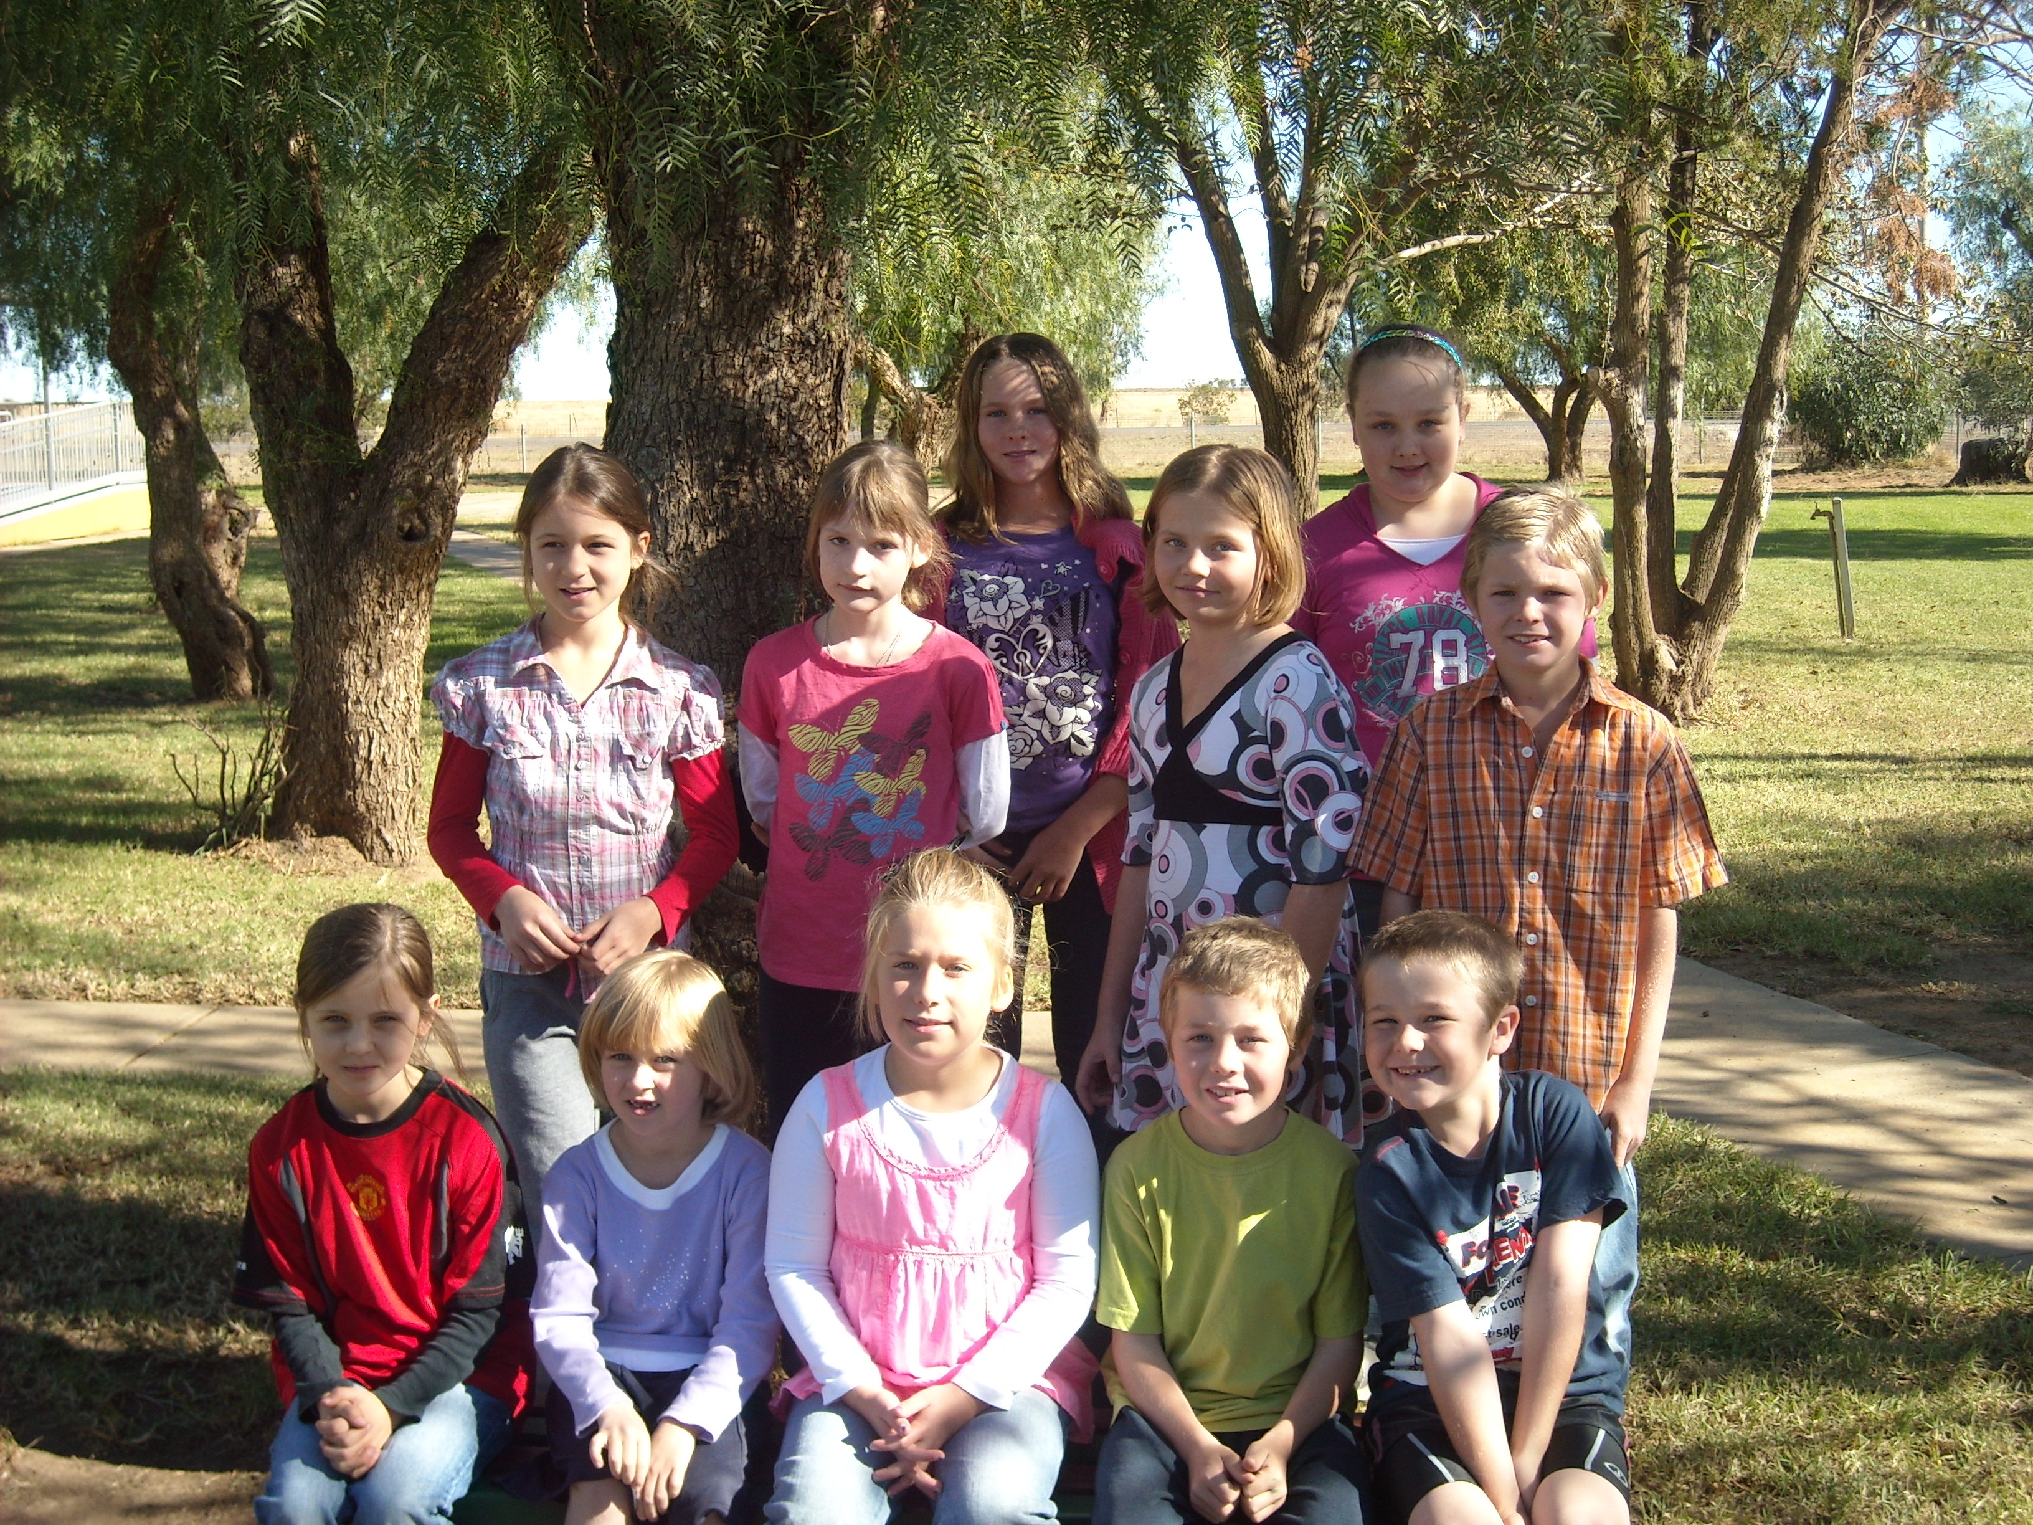

BOOKCLUB ORDERS
Book club order forms are attached to today’s Peppercorn Press. All orders and money must be back by Monday 7th June, 2010.

NSW DEPARTMENT & EDUCATION TIPS & IDEAS
Eco tip
Did you know? Australians are among the highest water users in the world.
What can you do? Turn off the tap while cleaning your teeth – you can save around 5 litres of water every time.
More tips at www.livingthing.net.au
Internet safety tip
Stranger danger is online too
Ensure your child never organises to meet up with any strangers that they have met online. If they really want to meet up, encourage them to talk to you about it first and insist on going along with them. Remind your children to also be wary opening emails from strangers too. They could contain spam (online junk mail), a virus (which will harm your computer), or be from a stranger looking for trouble.
More tips at www.schools.nsw.edu.au/click
Snack ideas
- Muffins - make with added mashed or diced fruits or grated vegetables.
- English muffin + cheese.
- Fruit loaf
- Scone - plain or fruit or pumpkin
- Pikelets
- Pita chips - cut pita bread into triangles, sprinkle with grated cheese and bake in moderate oven until crispy (store in airtight container).
- Homemade pizza - Lebanese bread + tomato paste + veggies + cheese.
- Wholemeal crackers + slice cheese.
- Small tub yoghurt - keep this cold with an ice-brick and an insulated bag.
- Cheese sticks.
More ideas at www.meerilinga.org.au

Encourage everyday physical activity
What you can say to your child to get them active:
- ‘It’s time to play outside now.’
- ‘Rex needs some practice fetching. It’d be great if you could go outside and throw the ball to him.'
- ‘Let’s walk to the shop to get the things we need for dinner.'
- ‘Wow, you’ve been jumping on the trampoline for ages.’
- ‘Keep going. Your sandcastle is getting so big.’
- ‘You did a fantastic job pulling the weeds out of the garden. It’s great when you help.’
- ‘You rode a really long way today on your bike – well done.’
More ideas at www.raisingchildren.net.au

P&C NEWS
HOT LUNCHES
We will be having our second Hot Lunch Day this Friday, 28th May 2010. Students will get a hot dog, a packet of chips and a juice box.

Please return the attached form no later than Thursday, 27th May 2010, together with payment of $4 per student if you would like them to participate.


COMMUNITY NEWS

AUSTRALIA’S BIGGEST MORNING TEA
Dear Carrathool & District Resident
You are cordially invited to join in for a cuppa for Cancer research as part of
AUSTRALIA’S BIGGEST MORNING TEA
at the Carrathool Memorial Hall
Thursday 27th May
Anytime from 9.45 am till 12 noon
A donation of your own choice would be appreciated.
Cancer council receipts will be given for donations of $2 and over.

ATTACHED TO NEWSLETTER
- Parent Information Sheet for Borambola Sport & Recreation Camp.
- Life Education Van Merchandise Order Form,
- Life Education Van Permission Note.
- Borambola Winter Sports Camps Flyer
- Book club Order Forms

