COMING EVENTS

Term 2

Week 8
Wednesday 9th June Uni Science Comp
Thursday 10th June Sarah Young Athletics’ Training Day in Hay
Friday 11th June Hay Small Schools’ Athletics’ Carnival

Week 9
Monday 14th June Queen’s Birthday Public Holiday
Tuesday 15th – Friday 18th June Yr 2-6 Borambola Excursion
Wednesday 16th June Mobile Library

Week 10
Monday 21st June Long Weekend
Wednesday 23rd June Assembly @ 2.00pm
Friday 25th June Yr 6 at Hay Public School

Week 11 – NAIDOC WEEK
Friday 2nd July Crazy Hair Day
Last Day Term 2

INDONESIAN AWARDS

Shara Blair | Baik Sekali – for excellent work in Indonesian.
Kaiti Morrow | Sempurna – for an excellent effort during Indonesian lessons.

HAPPY BIRTHDAY
Happy Birthday to
Sarah Merrylees – 6/6/10 – 8 yrs old
Sue Woods – 10/6/10

YR 2-6 BORAMBOLA EXCURSION
Final payment for this excursion needs to be paid by tomorrow (Wednesday 9th June.) The cost for this excursion is $100 for the first child, $50 each for subsequent children. Minus the $50 deposit per family already paid. Thank you to the P&C for subsidising this excursion. Travel arrangements will be finalised soon and you will be notified at the Athletics’ Carnival.

HIGHLY COMMENDED WITH COSTA
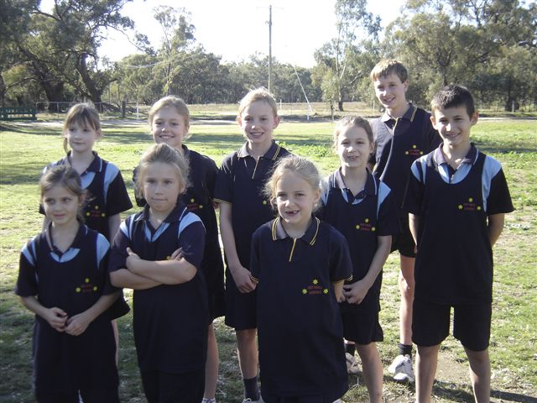
We are happy to announce Carrathool Public School’s entry has been awarded a highly commended prize in “Costa's Garden Odyssey 2010 Competition" and will receive Costa’s Garden Odyssey Series 1 and 2 on DVD.
SBS would like to thank Carrathool Public School for their entry and participation in this competition.

DISTRICT X-COUNTRY
Congratulations to our students who attended the District X-Country in Deniliquin. Many personal bests were achieved and the students were a credit to our school.
Well Done!


FRUIT FIRST
As part of our PD/H/PE subject we are introducing ‘Fruit First’ at recess. Could all children please bring a piece of fruit to eat first at recess. We also request that children do not bring chocolates or lollies to school.

MOBILE LIBRARY
The mobile library van will be visiting our school next week on Wednesday 16th June, 2010
As we will be away at Borambola next week, please could you send in all your children’s books this week. Thank you.

ATHLETICS’ TRAINING DAY WITH SARAH YOUNG
A reminder that our students will be travelling to Hay to attend an Athletics’ Training Session, being run by Sarah Young this Thursday 10th June, 2010.
Students and staff from Booligal PS will also be attending this day.
Students are to wear sports clothes and need to bring their recess, lunch, drink bottle and hat.
Volunteers will be needed to assist with the setting up of equipment in the morning of the training day and packing up of equipment at the completion of the training day. Please make yourself known to Sarah on the day, if you can offer some assistance.
If you have not already returned the permission slip sent home on 27th May please do so tomorrow; an extra permission note will be attached to your newsletter. Even if you don’t want your child to attend these days we still need to have the permission note returned.
All staff from Carrathool PS will be attending this event. Therefore, if you choose to not allow your child to participate in this event, then they must remain at home for the day as the school will not be open.
Parents will be responsible for transporting their own children to and from the Athletics’ Training Session in Hay.
The day will commence in at Hay at 9.30am and finish at 2pm.

SMALL SCHOOLS ATHLETICS CARNIVAL
Our Small Schools Athletics Carnival will be on Friday 11th June 2010 at the Hay Park near the High School.
Children need to be at Hay Park by 9.15am. The carnival will finish between 1.30 – 1.45pm.
There will be a BBQ run by Hay SOTA.
Parents will be responsible for transporting their own children to and from the Small Schools’ Athletics’ Carnival.
If you have any questions or concerns please do not hesitate to contact the school.

ASSEMBLY
We will be having an assembly on Wednesday 23rd June at 2.00pm. We would love to see you there.
After the assembly we will be having an afternoon tea for Kate Doyle as this will be her last day. Please bring a plate of food to share.

HEALTHY HAROLD ARTICLES
Healthy Harold
On Friday Healthy Harold came. We talked about smoking and how bad it is.
The first activity we had to do was that we had to pull chemicals out of a cigarette.
Some chemicals were rocket fuel, chemicals to embalm dead bodies, toilet cleaner and rat poison. Then we had to do a play on how to say no to cigarettes. It was fun.
After the play we watched some disgusting videos on cancer then we got to play with Harold and do some action games. It was fun.
By Kaiti

Healthy Harold
On Friday 28th May 2010 Healthy Harold visited Carrathool. Jackie told us about smoking and what can happen if you smoke. There were some really gross pictures in the van of where you can get cancer in your body if you smoke. We also saw what can happen to your lungs. We also learnt about dangerous chemicals in a cigarette.
We met Harold I played a ball game with him. He ate my hand. I bought a bouncy ball.
It was fun!
By Isabel
Healthy Harold
On Friday 28th May 2010 I saw Healthy Harold.
We were taught about how dangerous cigarettes are.
We learnt about the deadly chemicals that are in smokes.
We watched gross video clips about how smoking can cause cancer in many parts of the body.
I will never smoke.
By Jamie Blair
Healthy Harold
Last Friday the Life Education Van came to our school.
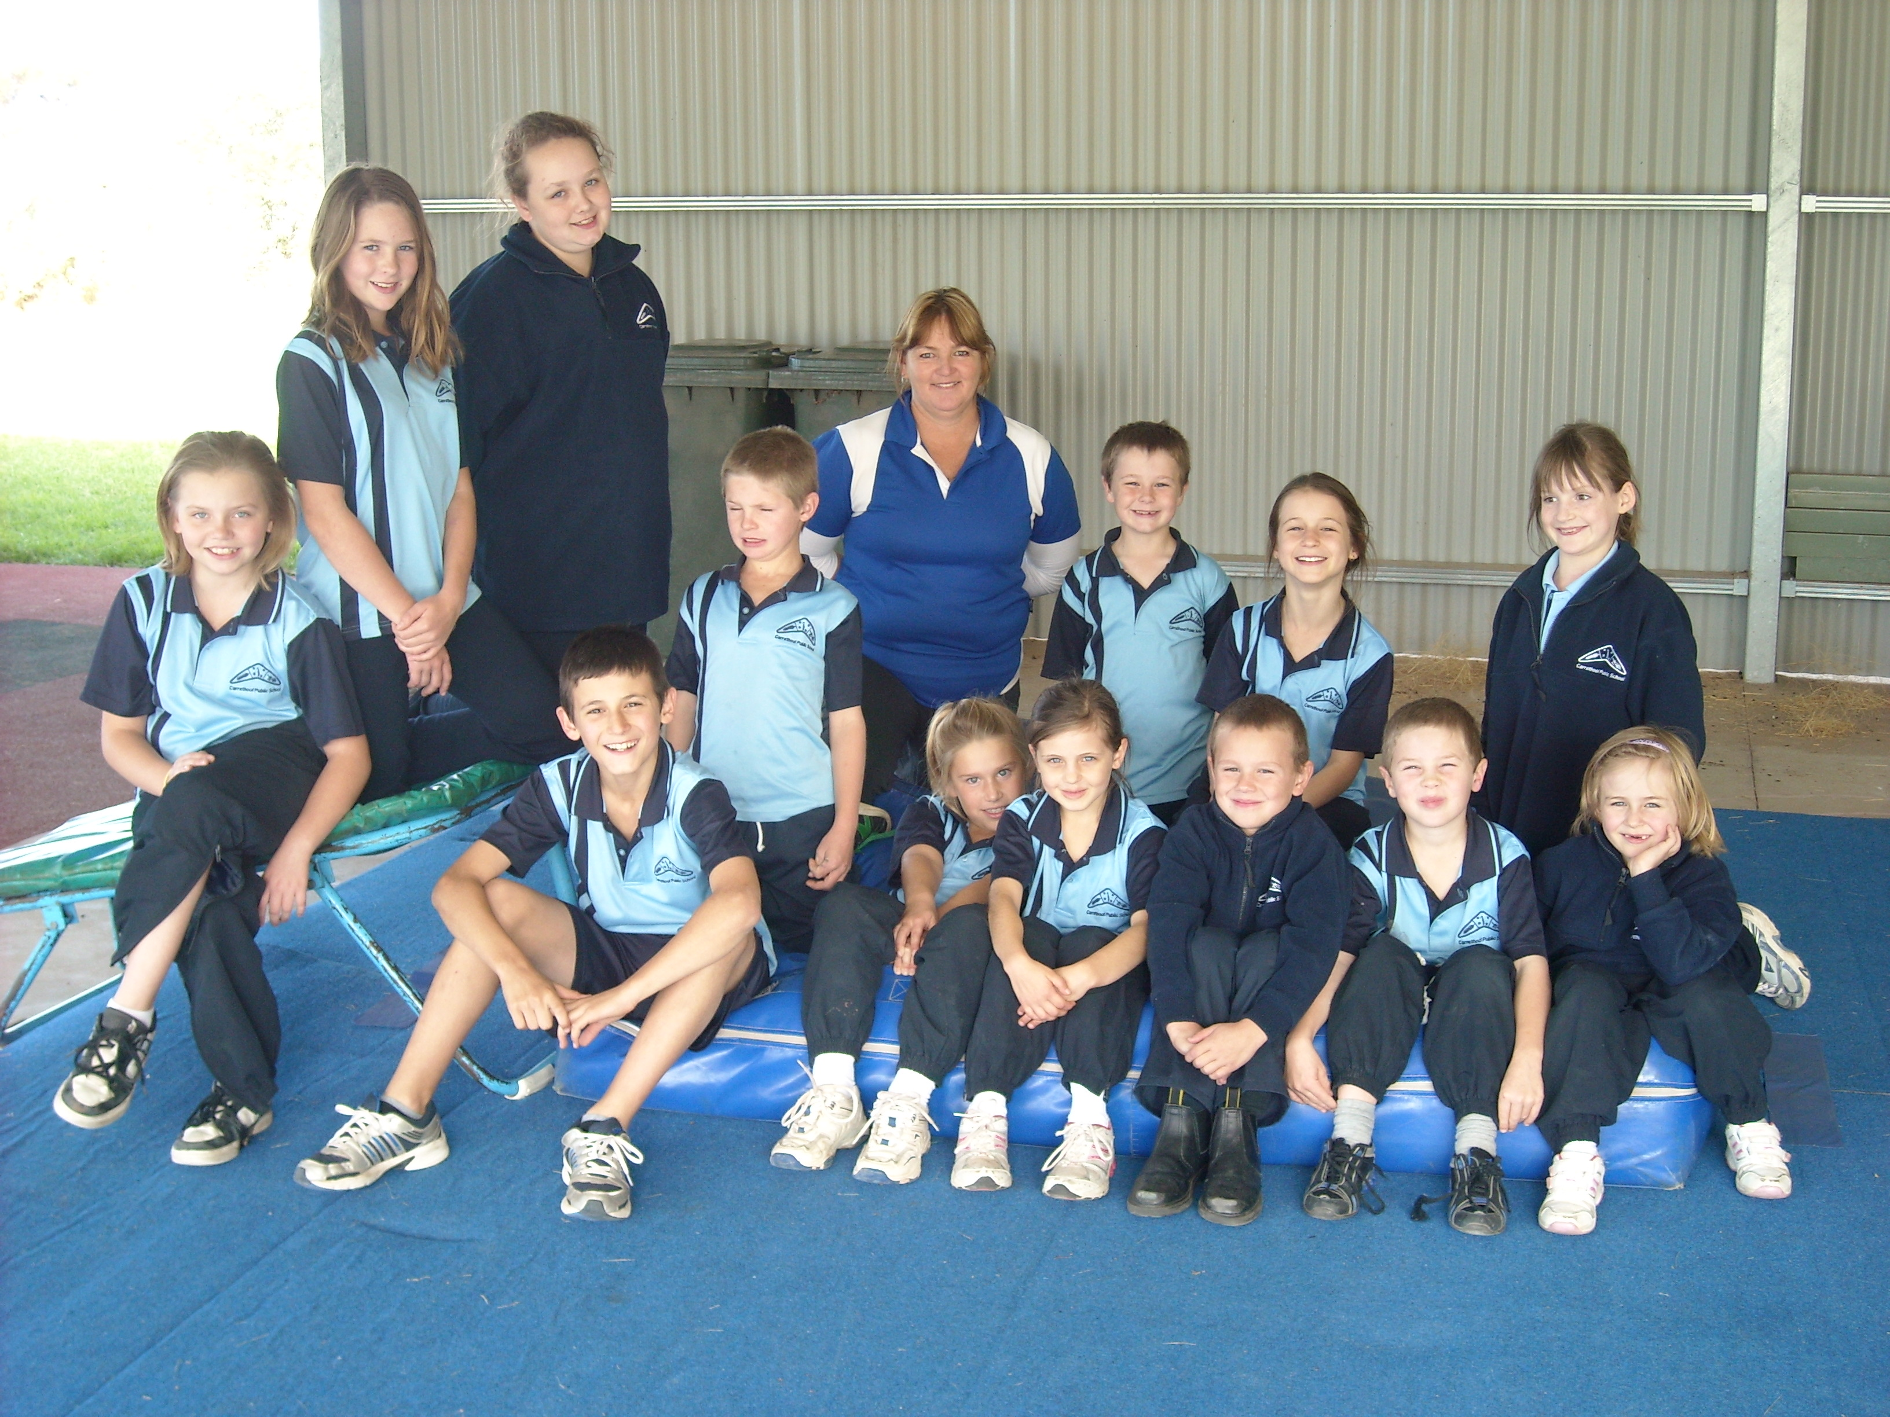
We learnt about how smoking hurts us.
Inside a cigarette there are many chemicals that can destroy the insides of your body and sometimes kill you.
When people are buying cigarettes other people are buying things that are not dangerous for you for the same price. So people that are smoking should stop.
After we learnt about what smoking does to you, we saw Healthy Harold and then went back to class. It was great.
By Emily Chick
Healthy Harold
On Friday I went to Healthy Harold and we talked about good and bad stuff. We got to see a Healthy Harold movie. The Healthy Harold movie was about a magic school bus going all over the world and even in the desert!! I got a Harold hand ball and Harold eraser.
By Sarah Merrylees
Healthy Harold
On Friday I went to Healthy Harold and we learn to not smoke when we grow up and don’t drink alcohol.
By Shane Blair
Healthy Harold
On Friday I went to Healthy Harold and I learnt about dangerous things.
By Chontelle Barton
Healthy Harold
On Friday I went to Healthy Harold and we watched a video about if you find a piece of glass do not touch it and tell your mum or dad. I got a hand ball and a key ring.
By Bradley Chick

LAST GYMNASTICS LESSON
The students enjoyed having gymnastics for the last 5 weeks and learnt a lot of different skills.

Below are some photos of their last lesson.

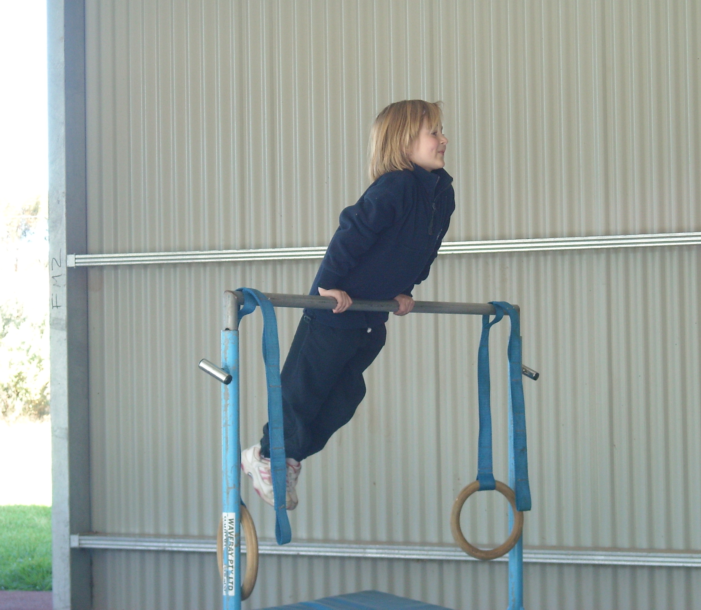
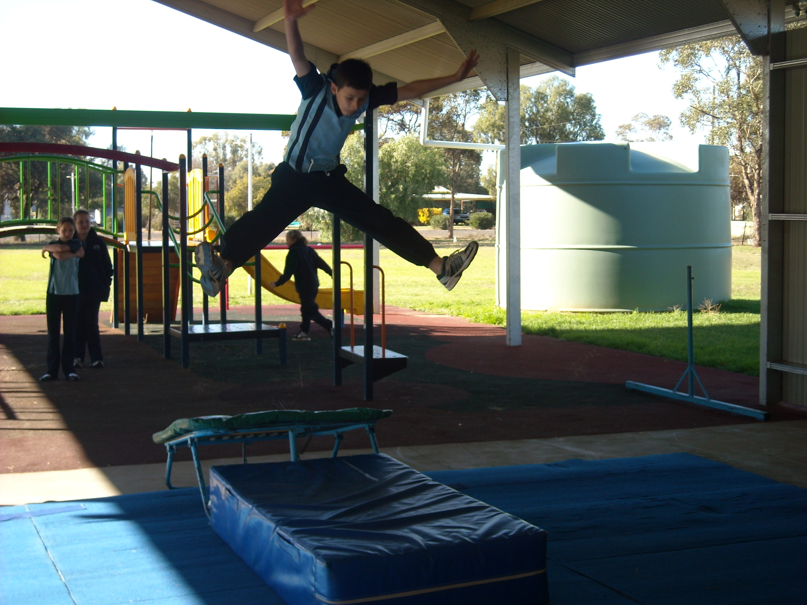

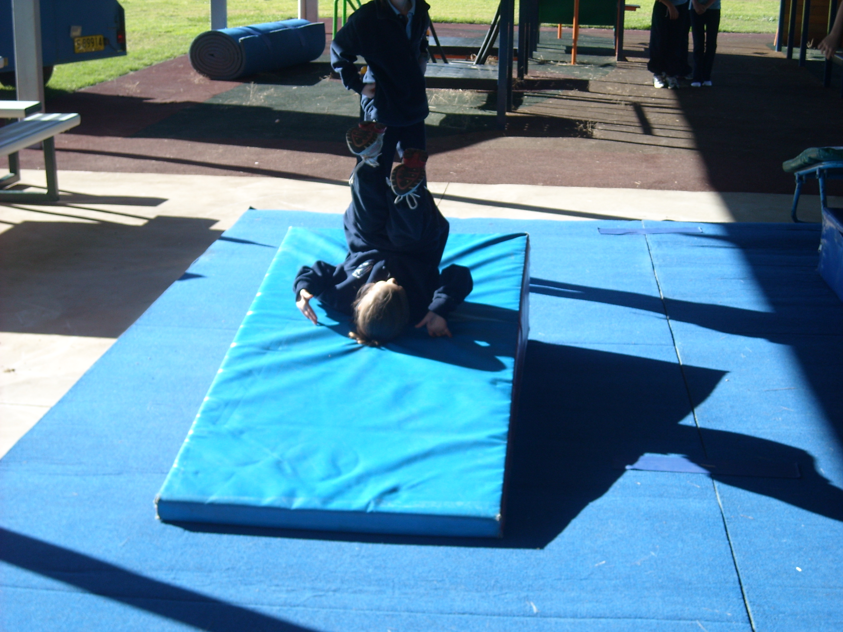

NSW DEPARTMENT OF EDUCATION & TRAINING TIPS
Internet Safety Tip
With the recent events occurring regarding the Internet and Facebook, I thought the advice below may be useful to our community;
Remind your child to keep information such as their name, address, phone number, school and even your credit card number to themselves. When signing up to a chat room, they should use a screen name that is a nickname and not easy to work out. The same goes for choosing passwords - don't make them easy to figure out. If your child is going to put photos on the Internet, ensure they don't show them wearing their school uniform – this can be enough to identify your child's school. Also ensure that any photos are not the type that would attract unwanted attention from strangers. More great advice at www.schools.nsw.edu.au/click



